DAY 1 EXPERIMENTS

**Question 1:**

Create a simple cloud software application for Flight Reservation System using any Cloud Service Provider to demonstrate SaaS include the necessary fields such as one way, round trip, From, to, Departure, Departure, Travelers &amp; Class, Fare Type, International and Domestic Flights etc. 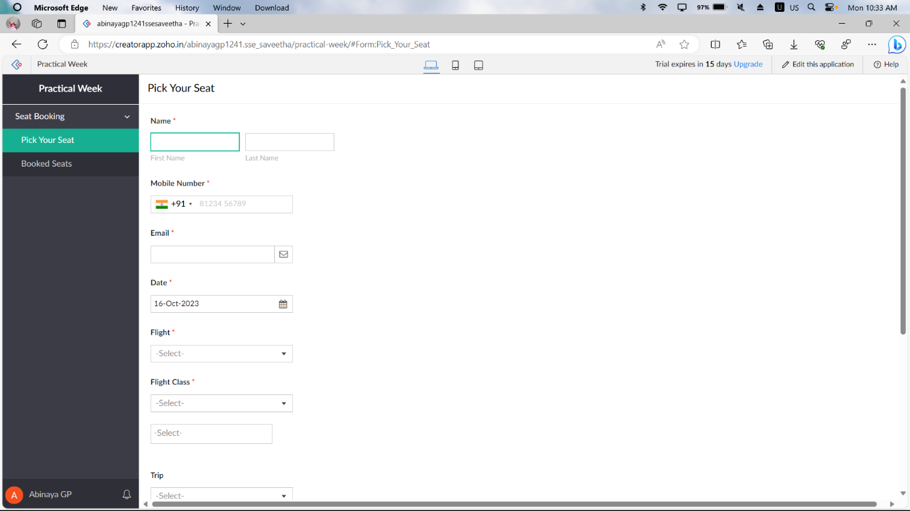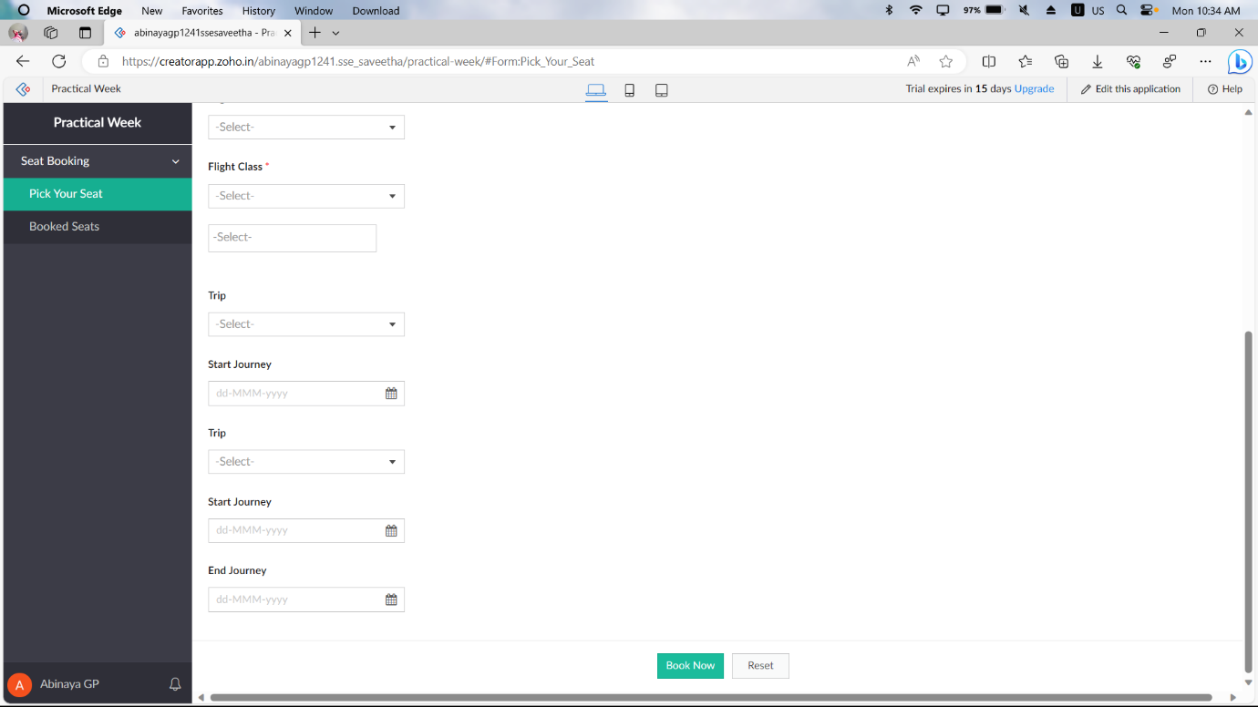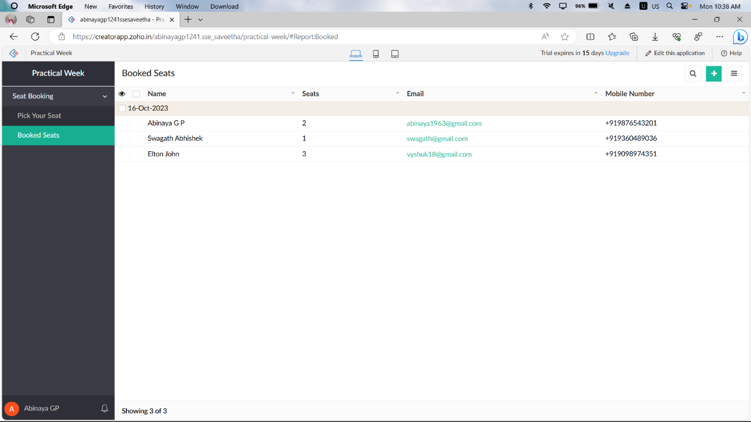

**Question 7:**

Create a simple cloud software application for Students Attendance System using any Cloud Service Provider to demonstrate SaaS include the necessary fields such as name of the students, course, present , Absent, course attendance, OD request, grade, attendance percentage, etc.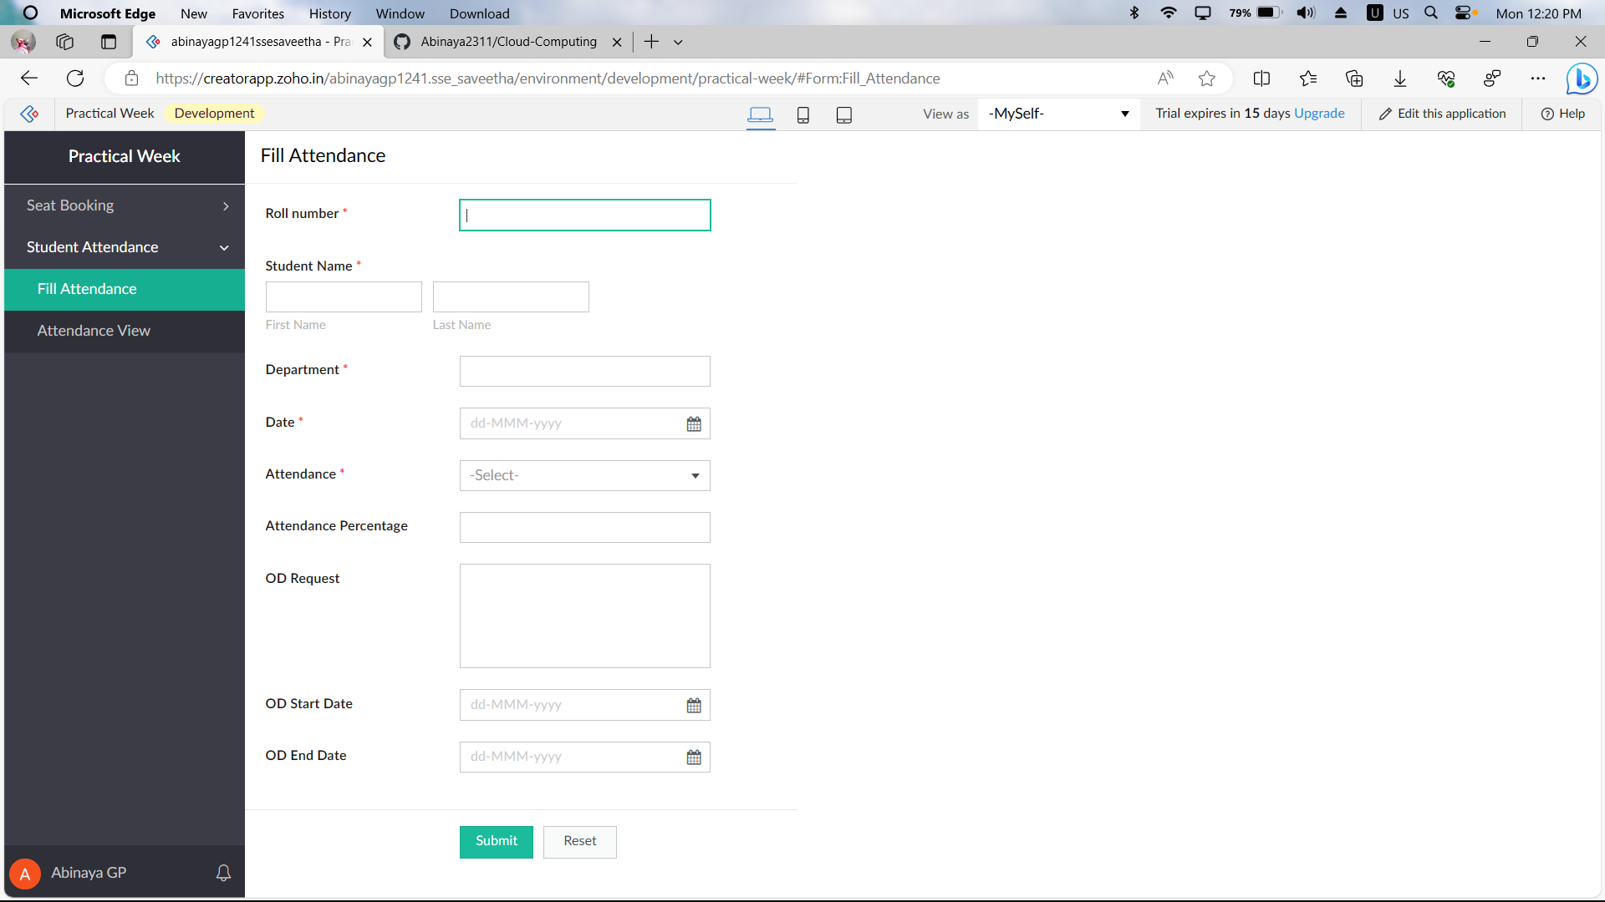

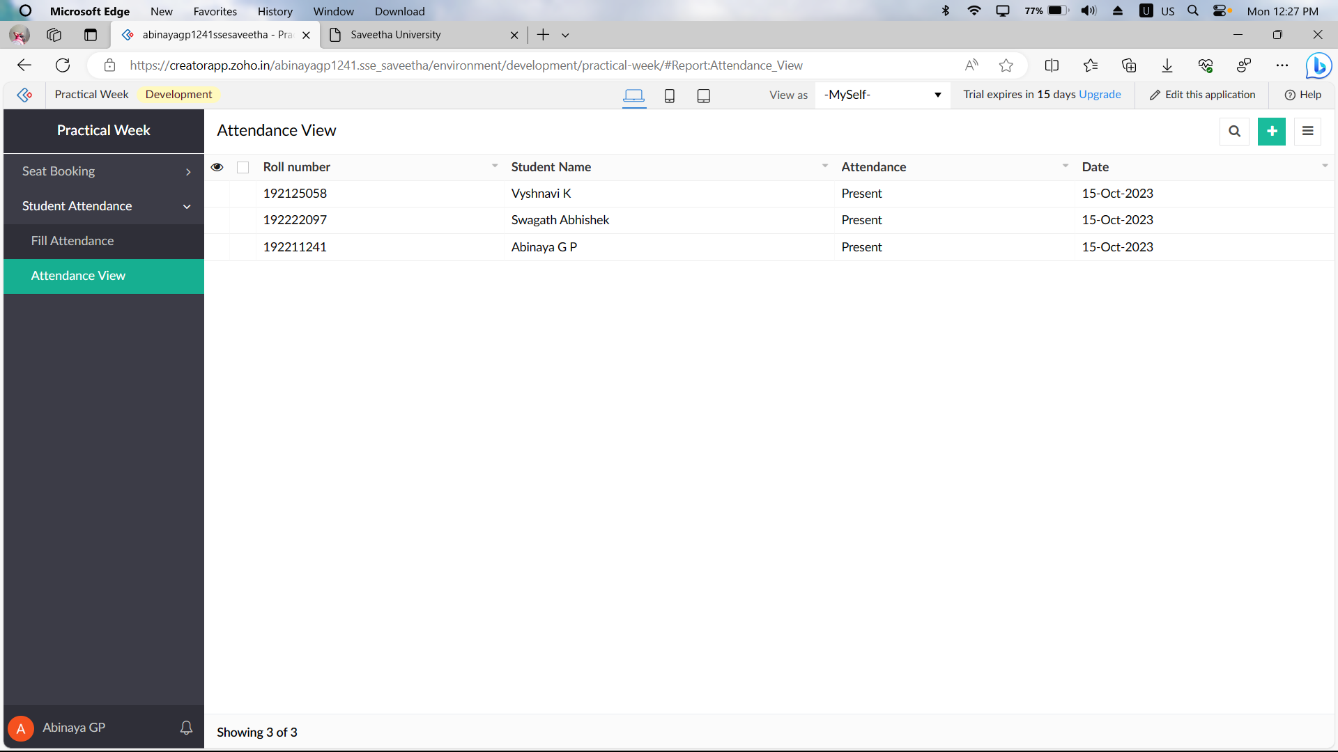

**Question 3:**

Create a simple cloud software application for Car Booking Reservation System using any Cloud Service Provider to demonstrate SaaS include the necessary fields such as search for cabs, from, to, rental , out station, Package type, hours/Days etc.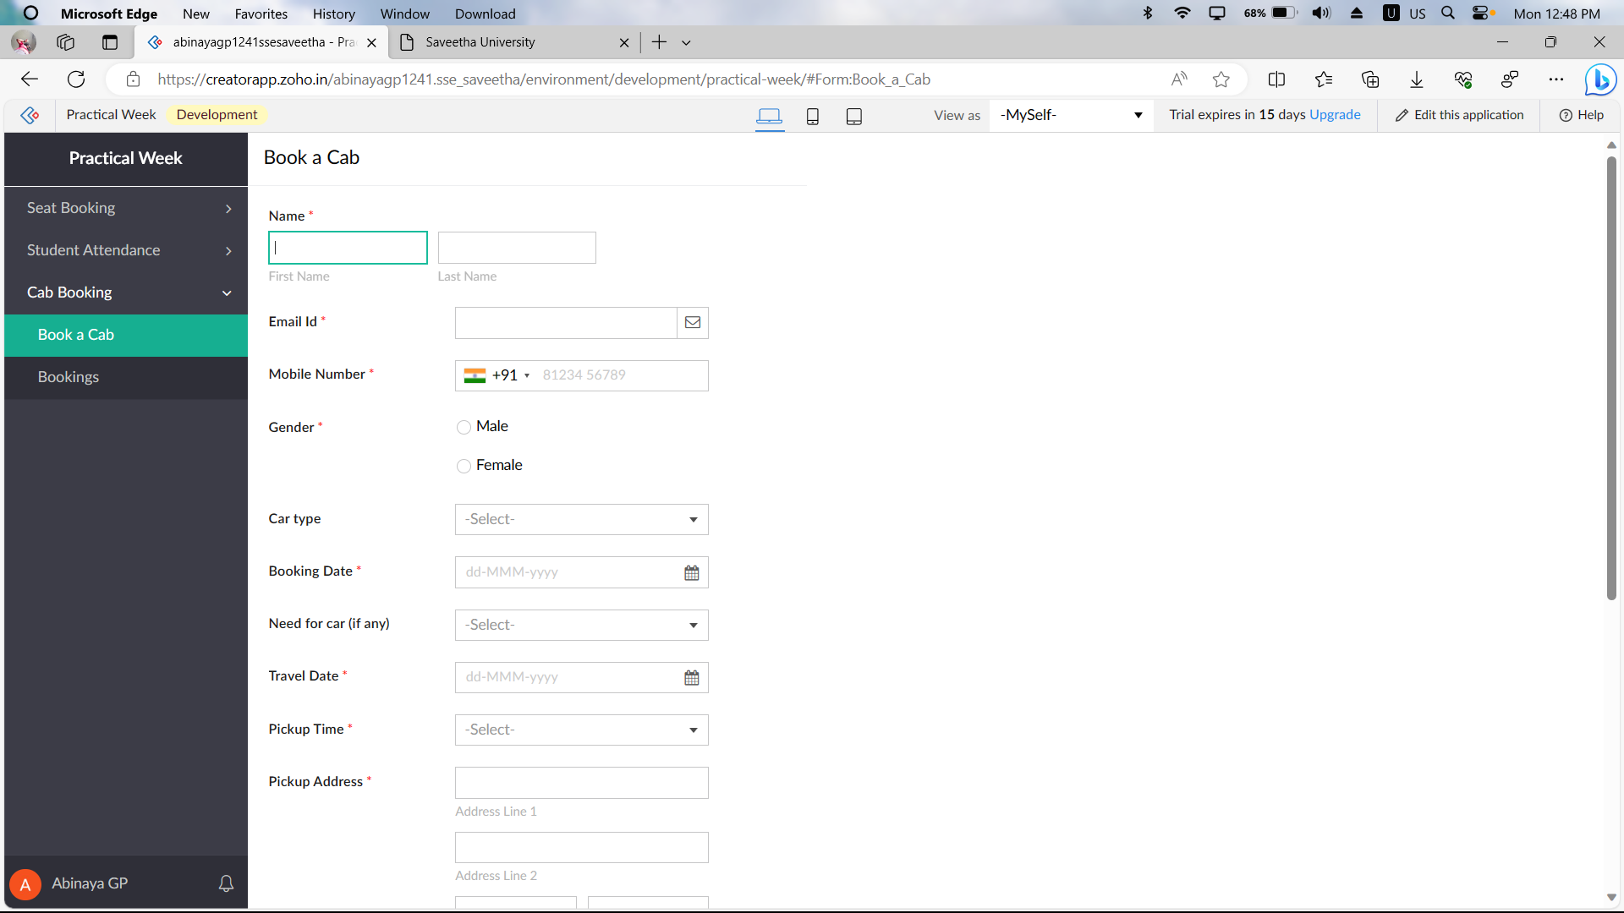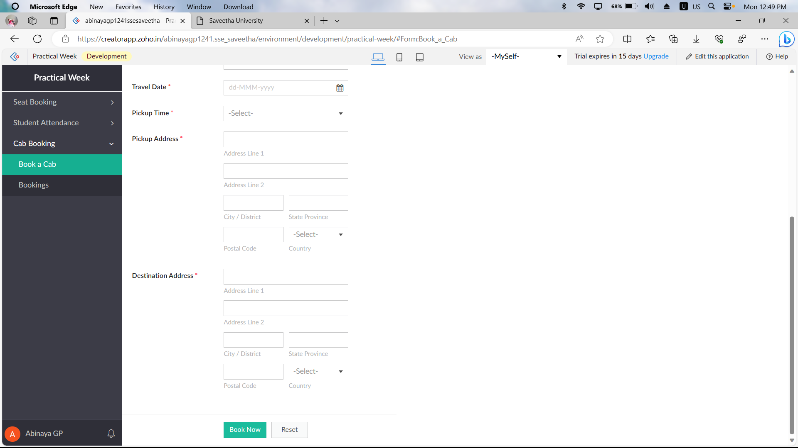 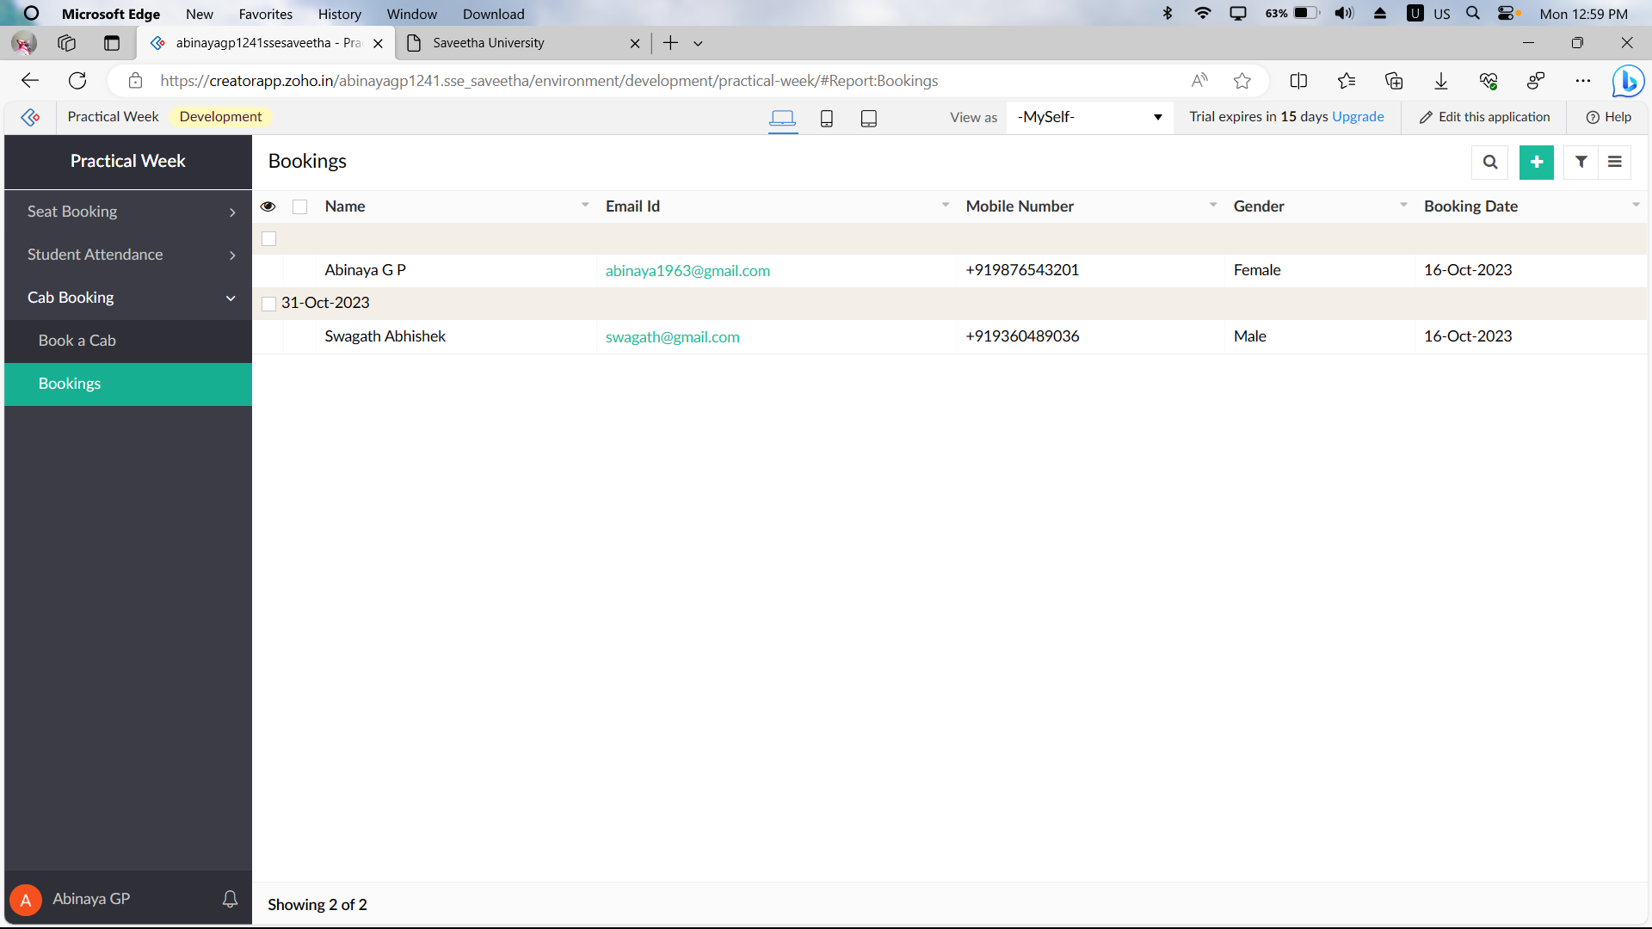

**Question 4:**

Create a simple cloud software application for Library book reservation system for SIMATS library using any Cloud Service Provider to demonstrate SaaS include the necessary fields such as Title of the book, author, publications, Year, edition, no of copies, Rack no, status (taken/returned) etc. 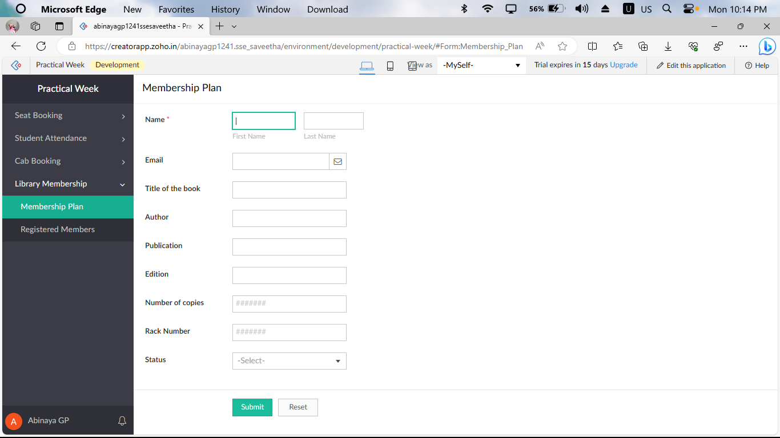 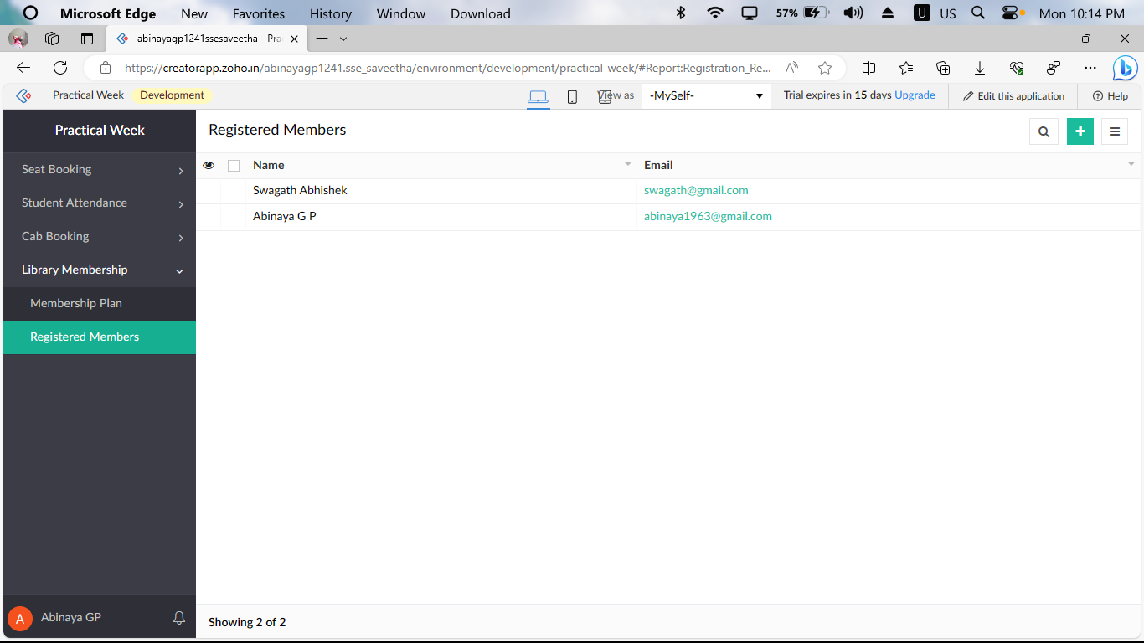

**Question 5:**

Create a simple cloud software application for Mark Sheet Processing System using any Cloud Service Provider to demonstrate SaaS include the necessary fields such as name of the student, Reg no of the student , Subjects , Marks, Average, percentage, rank, overall performance etc. 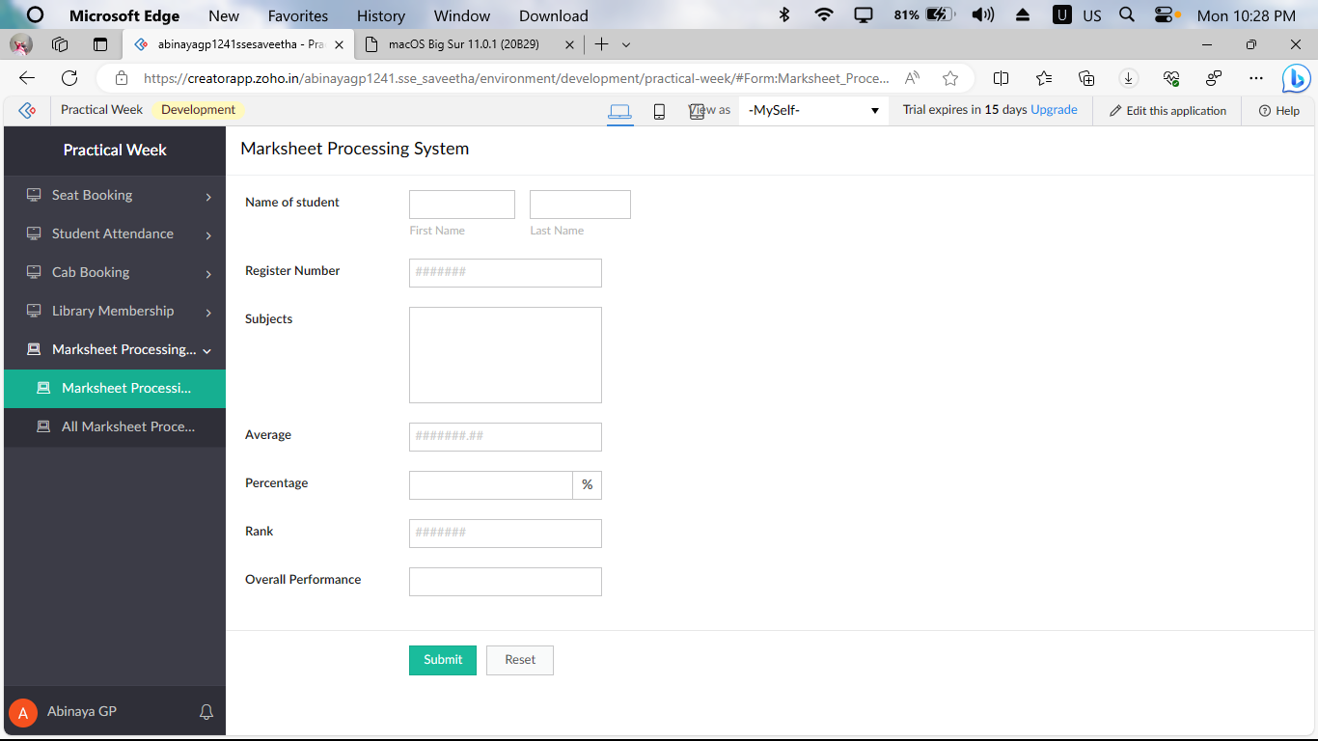 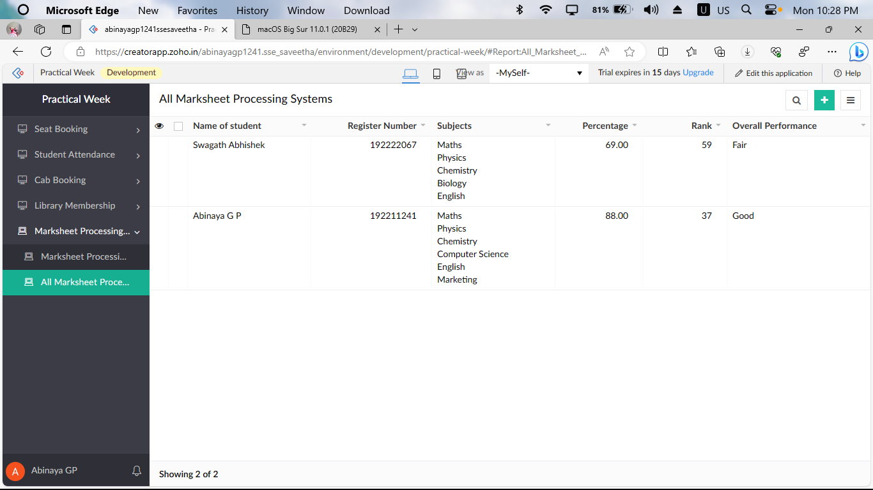

**Question 6:**

Create a simple cloud software application for Payroll Processing System using any Cloud Service Provider to demonstrate SaaS include the necessary fields such as Name of the employee, experience in present org , over all experience, basic pay, HRA, DA, TA, net pay, gross pay etc. 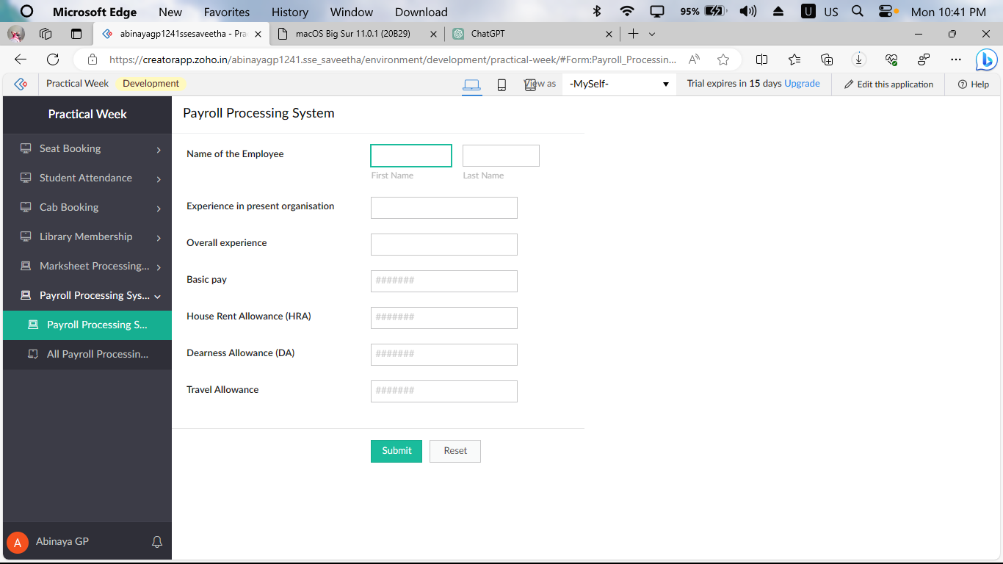 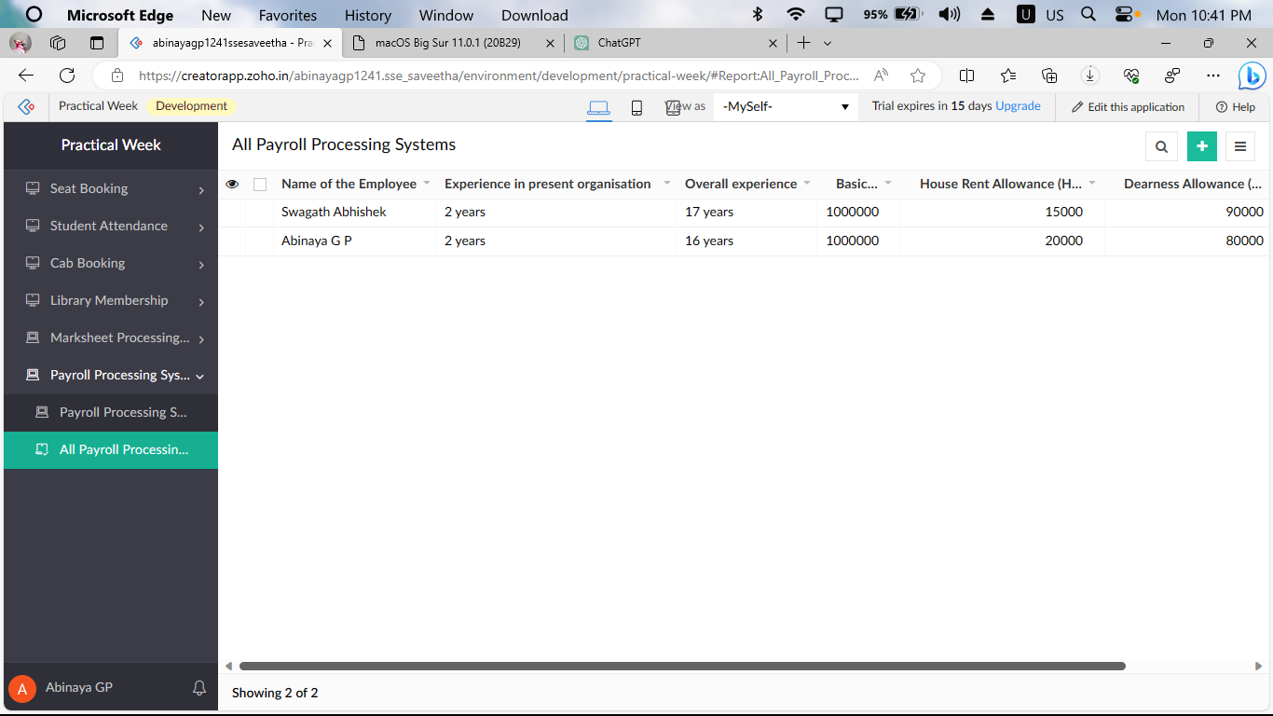

**Question 2:**

Create a simple cloud software application for Property Buying &amp; Rental process (In Chennai city) using any Cloud Service Provider to demonstrate SaaS include the necessary fields such as Buy, Rent, commercial, Rental Agreement , Rental Agreement, Area, place, Range, property value etc. 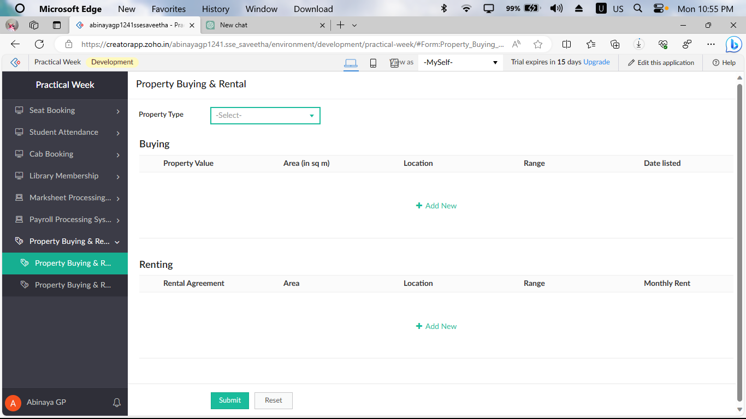 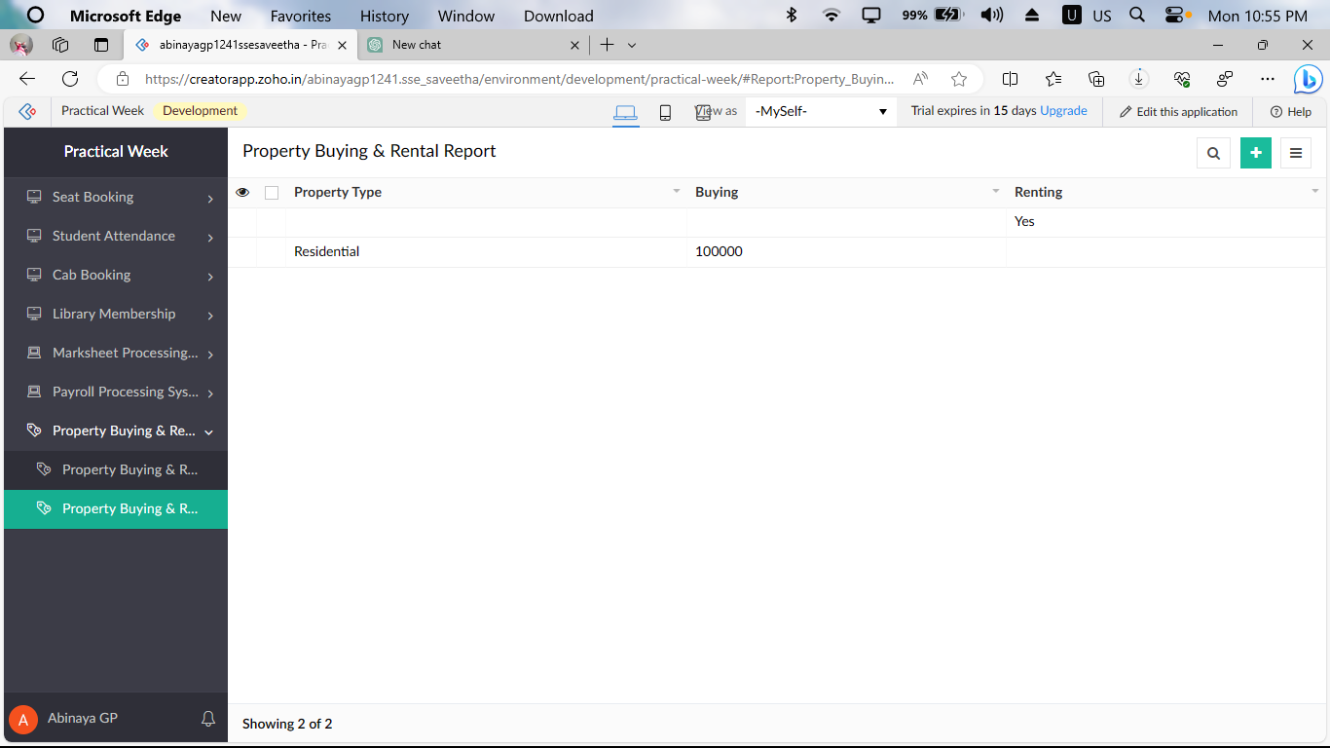

**Question 8:**

Create a simple cloud web application for student counselling system using any Cloud Service Provider to demonstrate SaaS with the fields of student name, age, address, phone, subjects studied, Year of passing, percentage of marks, domain interest, etc. 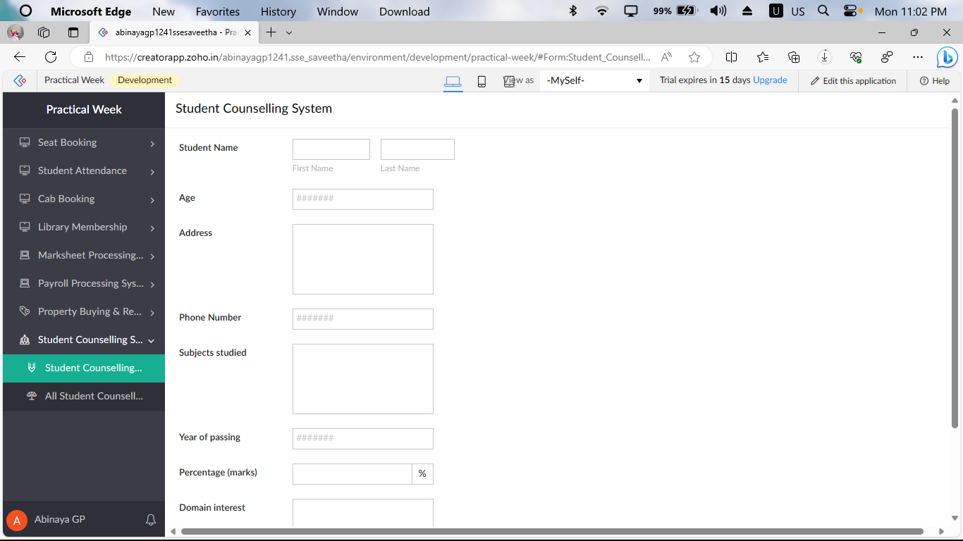 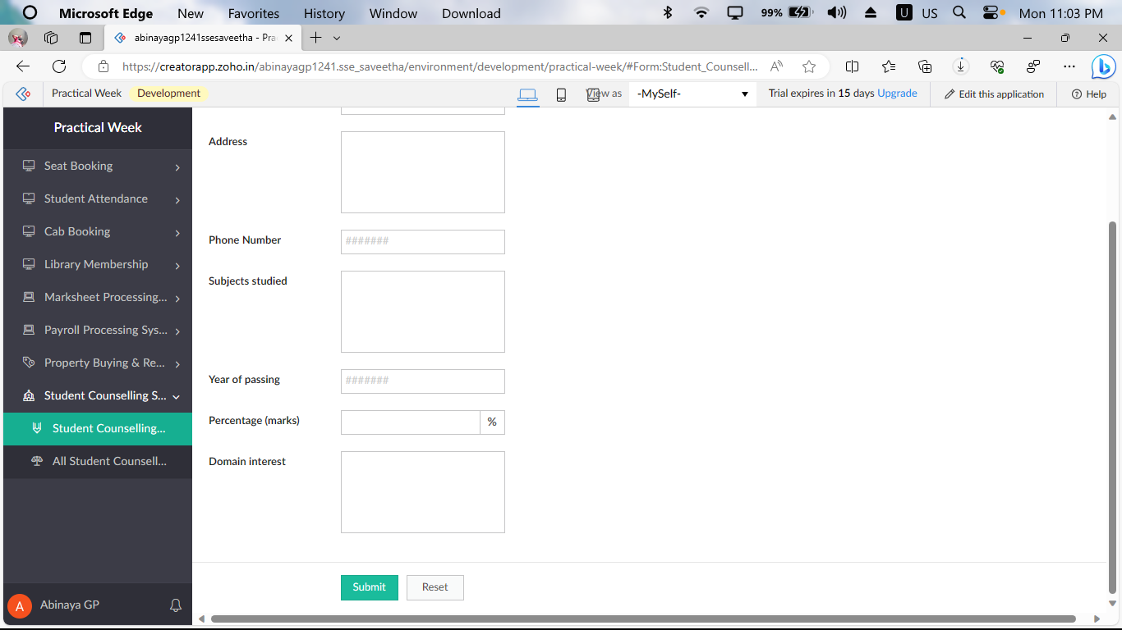 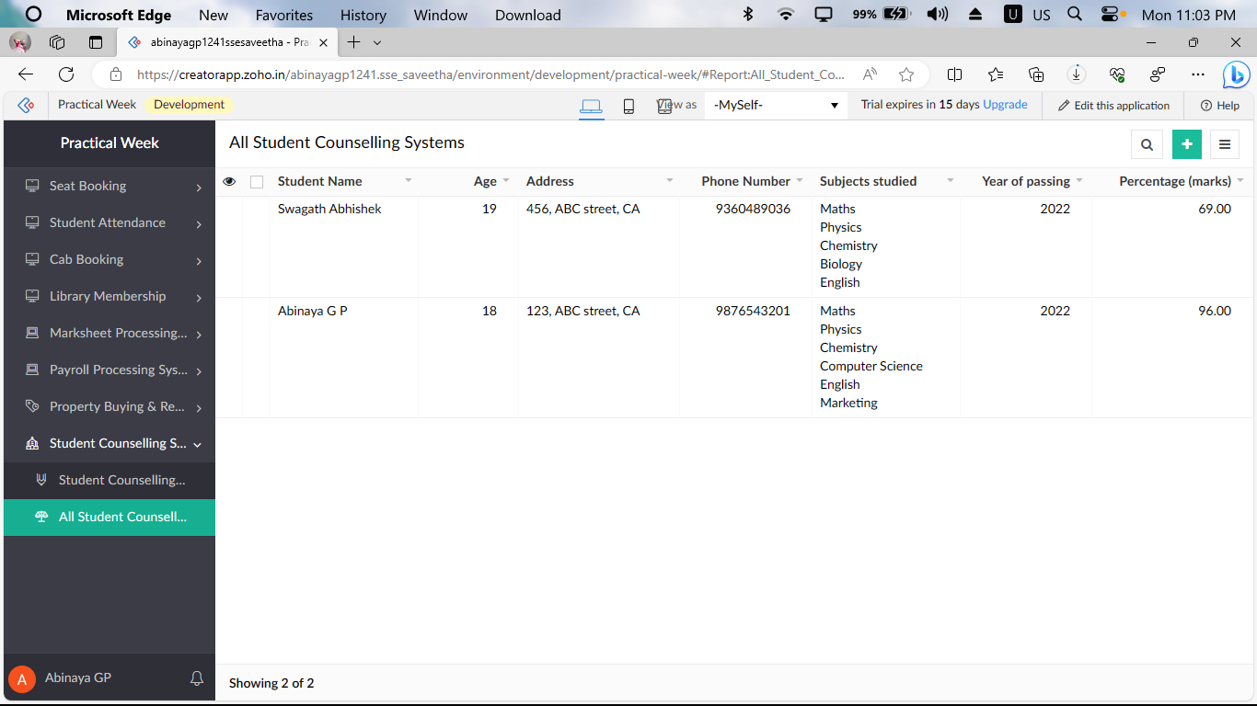

**Question 9:**

Create a simple cloud software application for Hospital information system for SIMATS Hospital using any Cloud Service Provider to demonstrate SaaS with fields of patient name, age, address, phone, email, Attender name, attender phone, doctor name, diseases, etc. 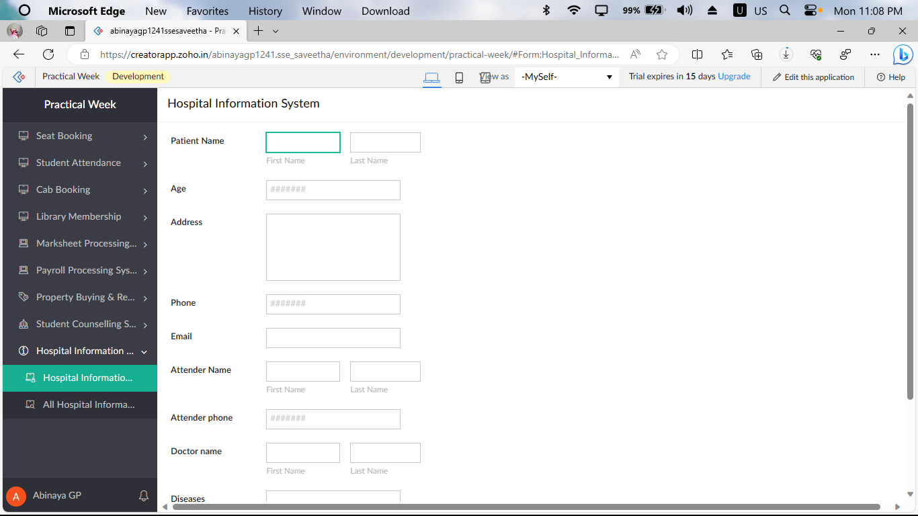 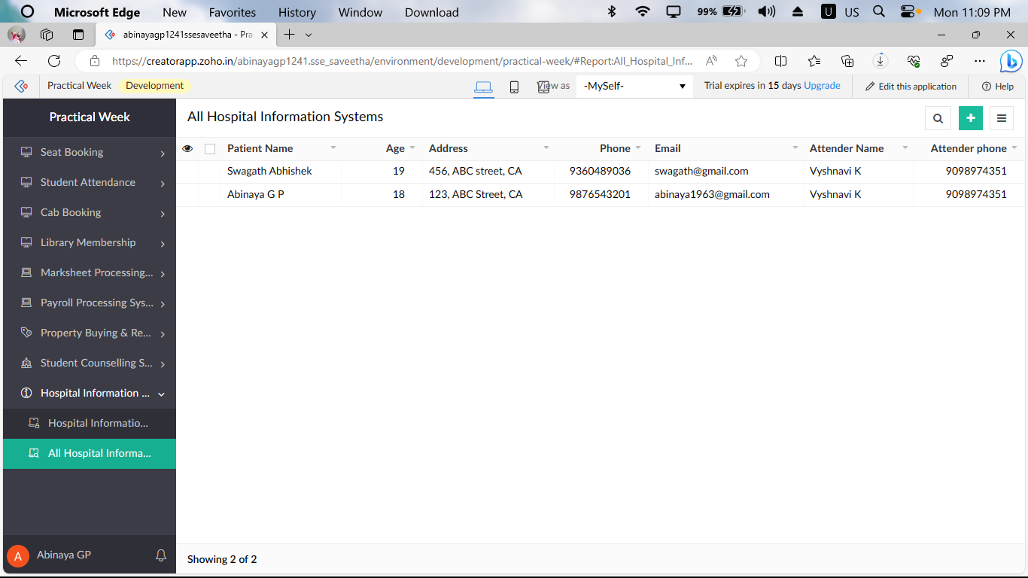

**Question 10:**

Create a simple cloud software application to run a c program to display the student information using any Cloud Service Provider to demonstrate SaaS with the template of student name, reg no, address, phone, age, courses, grades and attendance report, progress report, Semester mark sheet forms 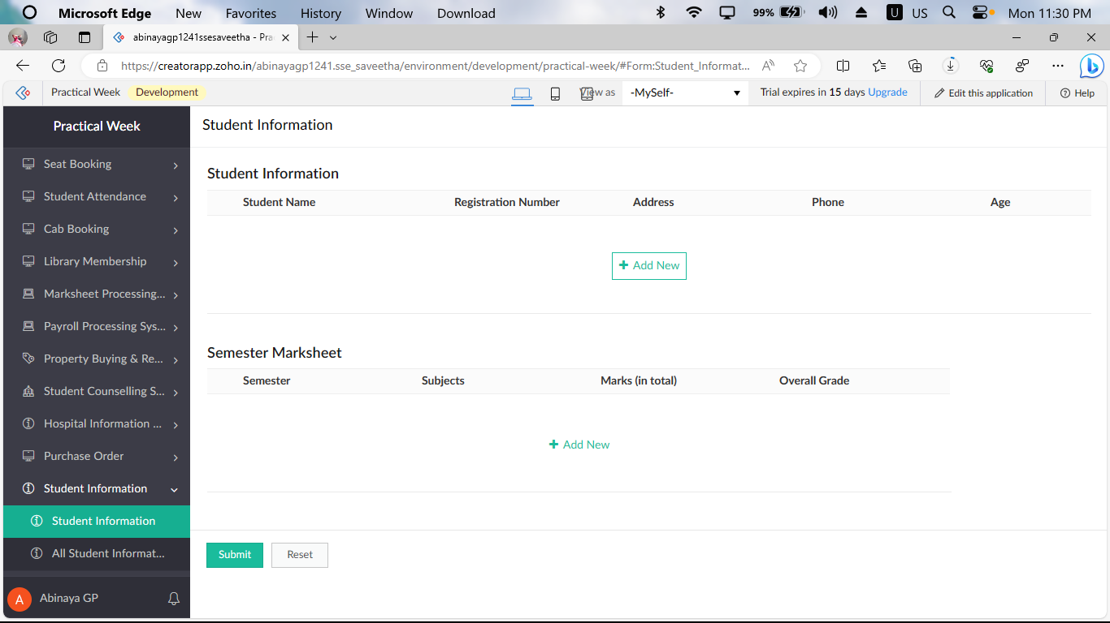 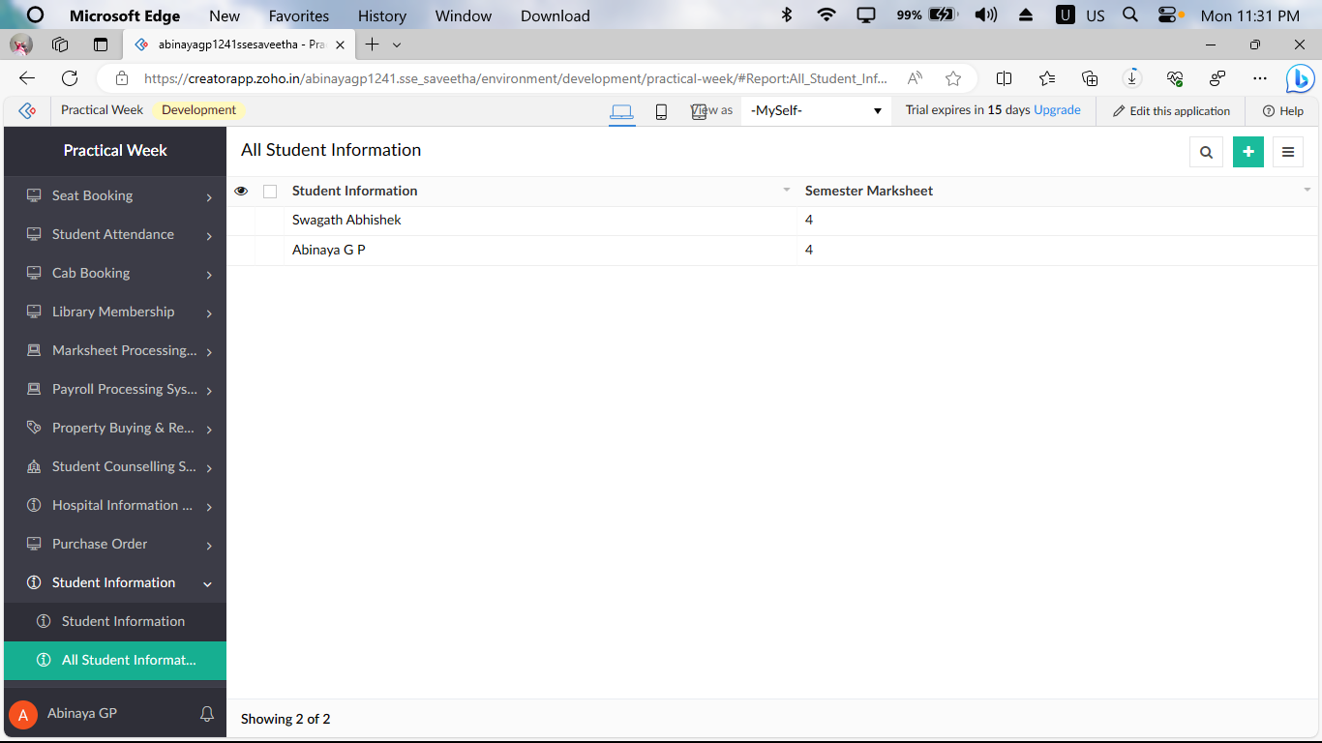

**Question 11:**

Create a simple cloud software application for online super market using any Cloud Service Provider to demonstrate SaaS with the template of customer name, address, phone, email, items, quantity etc. with the item classification form. 